Week 1: Demonstrate Version Control in Git and GitHub using Simple HTML Code

What is Git?
- Git is an open-source version control system that allows developers to track changes in their code, collaborate with others, and revert to previous versions if needed.
- It helps in managing project files across multiple contributors and ensures everyone works with the most up-to-date version of the code.

What is GitHub?
- GitHub is a cloud-based platform that uses Git for version control.
- It acts as a remote storage location for your Git repositories, making collaboration easier.
- It enables developers to share their code, work on it collaboratively, and manage issues or enhancements.

Objective of the Program
In Week 1, we demonstrate the use of Git and GitHub to:
- Create a simple HTML file.
- Use Git to track changes to the file.
- Push the file to a GitHub repository to showcase version control.

Steps and Their Significance

Step 1: Install Git
- Why?
  - Without Git installed, you can't use its commands to track changes or upload code to GitHub.
- How to Install Git?
  - Download Git from git-scm.com.
  - During installation, select "Add Git to PATH" so that the git command works in your terminal.
- Verify Installation
  - Run git --version to ensure Git is installed correctly.

Step 2: Create a Simple HTML File
- Why?
  - The index.html file serves as a simple example to demonstrate Git and GitHub functionality.
  - This file can later be used as part of a website project.
- HTML Example
<!DOCTYPE html>
<html>
<head>
<title>Version Control Demo</title>
</head>
<body>
<h1>Welcome to Version Control in Git and GitHub</h1>
<p>This is a simple HTML file to demonstrate version control.</p>
</body>
</html>

Step 3: Initialize Git
- Command: git init
- Why?
  - This initializes a new Git repository in the current folder.
  - A hidden .git folder is created to track changes.
  - Without this step, Git cannot track the file.

Step 4: Stage the HTML File
- Command: git add index.html
- Why?
  - The add command tells Git which files to include in the next commit.
  - It’s like preparing a box of files for shipping (the commit).

Step 5: Commit the Changes
- Command: git commit -m "Initial commit: Added simple HTML file"
- Why?
  - A commit records a snapshot of the project at a specific point in time.
  - The -m flag allows you to write a message describing the commit (e.g., "Initial commit").

Step 6: Create a Repository on GitHub
- Why?
  - GitHub serves as a remote repository where your local repository is stored online.
  - This allows you to share your code with others and access it from anywhere.
- How?
  - Log in to GitHub, click on "New Repository," name it (e.g., version-control-demo), and create the repository.

Step 7: Link Local Repository to GitHub
- Command: git remote add origin https://github.com/<your-username>/version-control-demo.git
- Why?
  - The remote add command links your local repository to a GitHub repository.
  - The name origin is a default name used for the primary remote repository.

Step 8: Push the Code to GitHub
- Command: git push -u origin main
- Why?
  - This command uploads your local commits to the main branch of the GitHub repository.
  - The -u flag sets the main branch as the default branch for future pushes.

Example to Illustrate Git and GitHub Workflow

Scenario:
Imagine you’re working on a school project with two friends. Each of you makes changes to the project at different times. Without a version control system, it’s hard to keep track of who changed what and avoid overwriting each other's work.
Git and GitHub solve this problem:
- You initialize a Git repository for the project on your computer (git init).
- You create a project file (e.g., project.txt) and commit the changes (git add, git commit).
- You push the code to GitHub so your friends can access it (git push).
- Your friends clone the project from GitHub, make their changes, and push them back.
- Git tracks all changes, so you can see the history and resolve conflicts.

Recap of Git Commands and Their Significance
Command | Purpose
git init | Initializes a new Git repository in your folder.
git add <filename> | Stages files for the next commit.
git commit -m "<message>" | Saves changes to the repository with a descriptive message.
git remote add origin <URL> | Links the local repository to a remote repository (e.g., on GitHub).
git push -u origin <branch> | Pushes changes to the remote repository, creating the branch if necessary.

Significance of Version Control
- Collaboration: Multiple developers can work on the same project without overwriting each other’s work.
- History: You can view the history of changes and revert to previous versions if needed.
- Backup: The code is stored on GitHub, acting as a backup in case your local files are lost.
Version 2

Step 1: Create the Simple HTML File
- Open any code editor (e.g., Visual Studio Code or Notepad++) and create a new file.
- Save the file as index.html.
html
Copy code
<!DOCTYPE html>
<html>
<head>
<title>Version Control Demo</title>
</head>
<body>
<h1>Welcome to Version Control in Git and GitHub</h1>
<p>This is a simple HTML file to demonstrate version control.</p>
</body>
</html>
Explanation:
- <!DOCTYPE html>: Declares the document type as HTML5.
- <head>: Contains metadata about the document (e.g., the title).
- <body>: Contains the main content displayed on the webpage.
- <h1>: Defines a large heading.
- <p>: Defines a paragraph.

Step 2: Initialize Git and Commit the File
- Open a terminal or command prompt in the folder where the index.html file is saved.
- Run the following commands step by step:
Command 1: Initialize the Git repository
git init
- Initializes a new Git repository in the current folder.
- A hidden folder .git is created, which tracks the changes.

Command 2: Add the HTML file
git add index.html
- Stages the index.html file, preparing it for a commit.

Command 3: Commit the file
git commit -m "Initial commit: Added simple HTML file"
- Records the changes in the repository with the message "Initial commit: Added simple HTML file".

Step 3: Create a GitHub Repository
- Open GitHub and log in to your account.
- Click on the New Repository button.
- Name your repository (e.g., version-control-demo).
- Keep it Public and click Create Repository.
- GitHub will display instructions to connect your local repository to GitHub.

Step 4: Link the Local Repository to GitHub
Run the following commands in your terminal:
Command 1: Add the remote repository
git remote add origin https://github.com/your-username/version-control-demo.git
- Replace your-username with your GitHub username.

Command 2: Push the code to GitHub
git push -u origin main
- This uploads the commit to the main branch of the GitHub repository.

Step 5: Verify on GitHub
- Open your GitHub repository in a browser.
- You should see the index.html file uploaded.
ERROR 1:
PS C:\Users\DELL-7490\Desktop\New folder> git init git : The term 'git' is not recognized as the name of a cmdlet, function, script file, or operable program. Check the spelling of the name, or if a path was included, verify that the path is correct and try again. At line:1 char:1 + git init + ~~~ + CategoryInfo : ObjectNotFound: (git:String) [], CommandNotFoundException + FullyQualifiedErrorId : CommandNotFoundException
Installation of GIT:
The error indicates that Git is not installed or not configured correctly on your system. Here's how you can resolve this issue:
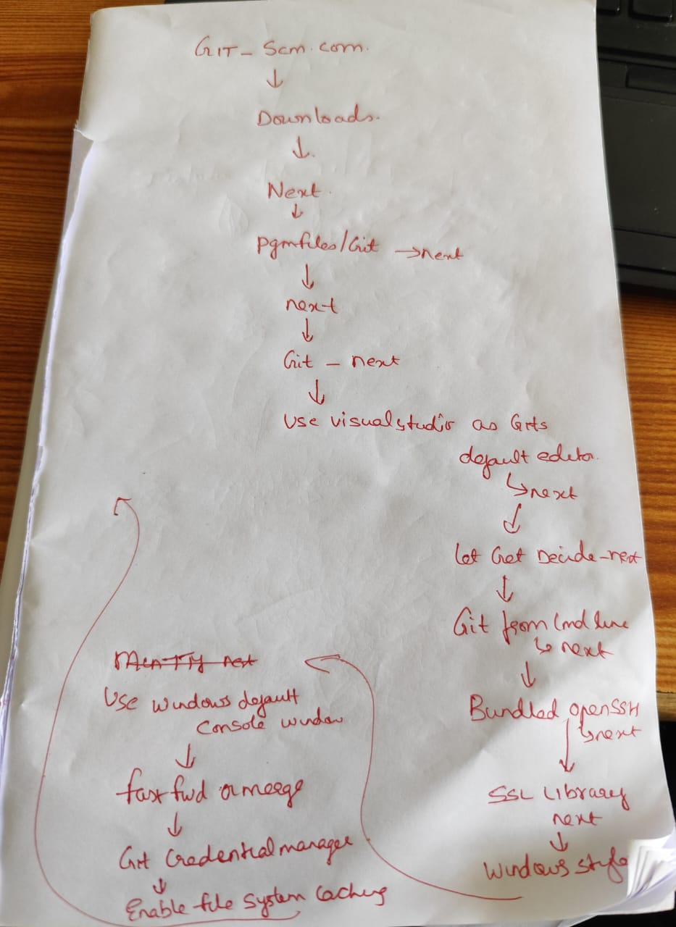

Step 1: Install Git
- Download Git:
  - Go to the official Git website: https://git-scm.com/.
  - Download the latest version of Git for Windows.
- Install Git:
  - Run the installer you downloaded.
  - During installation, ensure the option "Add Git to PATH" is selected. This allows you to use Git from the command line.

Step 2: Verify Git Installation
- Open a new terminal or Command Prompt.
- Type the following command to check if Git is installed:
git --version
  - If installed correctly, it will display the version of Git (e.g., git version 2.x.x).

Step 3: Configure Git (First-Time Setup)
- Set your username:
git config --global user.name "Your Name"
Replace "Your Name" with your name.
- Set your email address:
git config --global user.email "your-email@example.com"
Replace "your-email@example.com" with your email address.

Step 4: Retry the Commands
Once Git is installed and configured, retry the commands for initializing a repository:
git init
git add index.html
git commit -m "Initial commit: Added simple HTML file"

Step 5: If Issue Persists
- Ensure that the git command is available in your terminal:
  - Open Command Prompt and type echo %PATH%. Check if the Git installation path is listed.
  - If not, you may need to reinstall Git and ensure the "Add Git to PATH" option is selected.
Error 2:
PS C:\Users\DELL-7490\Desktop\New folder> git remote add origin https://github.com/786-Afshan/version-control-demo.git error: remote origin already exists. PS C:\Users\DELL-7490\Desktop\New folder> git push -u origin main error: src refspec main does not match any error: failed to push some refs to 'https://github.com/786-Afshan/version-control-demo.git' PS C:\Users\DELL-7490\Desktop\New folder>
The errors you are encountering are common in Git workflows. Let's resolve each issue step by step.

Error 1: "Remote origin already exists"
This error occurs because you already added a remote repository named origin.

Solution:
- Check the existing remotes:
git remote -v
This will display the currently configured remote repositories.
- If the remote URL is correct, you can skip adding it again. If not, you can remove and re-add the correct remote:
git remote remove origin
git remote add origin https://github.com/786-Afshan/version-control-demo.git

Error 2: "src refspec main does not match any"
This error occurs because there are no commits in your local repository yet, so the main branch doesn't exist.

Solution:
- Ensure you have committed your changes:
git add index.html
git commit -m "Initial commit: Added simple HTML file"
- Check your branch name:
git branch
  - If the branch name is not main but something else (e.g., master), use that branch name in the git push command:
git push -u origin master
- If your branch is not named main but you want to rename it:
git branch -M main
- Then push to the main branch:
git push -u origin main

Error 3: "Failed to push some refs"
This error usually occurs if your local branch doesn't match the remote branch.

Solution:
- Ensure the correct branch name is being used. Follow the steps above to confirm the branch name.
- If there’s still an issue, you can force push (only if you are sure):
git push -u origin main --force

Final Steps
Once you have resolved the issues:
- Run:
git remote -v
  - Ensure the remote URL matches https://github.com/786-Afshan/version-control-demo.git.
- Verify that the index.html file is uploaded to your GitHub repository.
can you again tell me what i should do for week 1
Here’s a step-by-step guide for Week 1, tailored to your current situation, to ensure everything works smoothly:

Objective:
Demonstrate version control in Git and GitHub by uploading a simple HTML file.

Step 1: Create a Simple HTML File
- Open any code editor (e.g., Notepad, VS Code).
- Write the following code and save it as index.html in a folder (e.g., C:\Users\DELL-7490\Desktop\New folder):
<!DOCTYPE html>
<html>
<head>
<title>Version Control Demo</title>
</head>
<body>
<h1>Welcome to Version Control in Git and GitHub</h1>
<p>This is a simple HTML file to demonstrate version control.</p>
</body>
</html>

Step 2: Initialize Git in the Folder
- Open Command Prompt or PowerShell.
- Navigate to the folder where you saved index.html:
cd "C:\Users\DELL-7490\Desktop\New folder"
- Initialize a Git repository:
git init
  - This creates a .git folder in your directory, enabling Git to track changes.

Step 3: Stage and Commit Your HTML File
- Stage the file:
git add index.html
- Commit the file with a message:
git commit -m "Initial commit: Added simple HTML file"

Step 4: Link to Your GitHub Repository
- Add the GitHub repository as a remote:
git remote add origin https://github.com/786-Afshan/version-control-demo.git
  - If you see an error saying "Remote origin already exists", run:
git remote set-url origin https://github.com/786-Afshan/version-control-demo.git

Step 5: Push Your Changes
- Rename your branch to main if it’s not already:
git branch -M main
- Push your code to GitHub:
git push -u origin main

Step 6: Verify on GitHub
- Go to your GitHub repository (https://github.com/786-Afshan/version-control-demo).
- You should see the index.html file in the repository.

